**UI/UX Design**

**SKETCHES**: (Basic structure of webpage to construct)

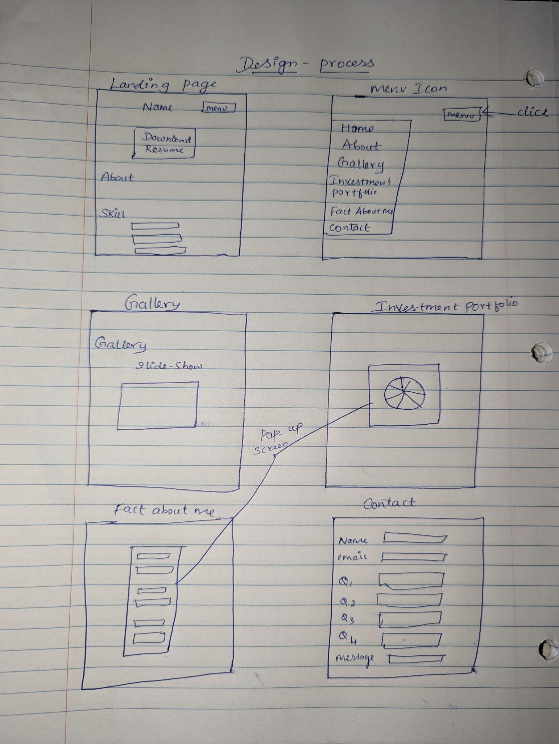

**RESPONSIVE DESIGN**

It is imperative to use responsive design, and as a designer, one of my key objectives is to produce user-friendly, adaptable designs and functions.

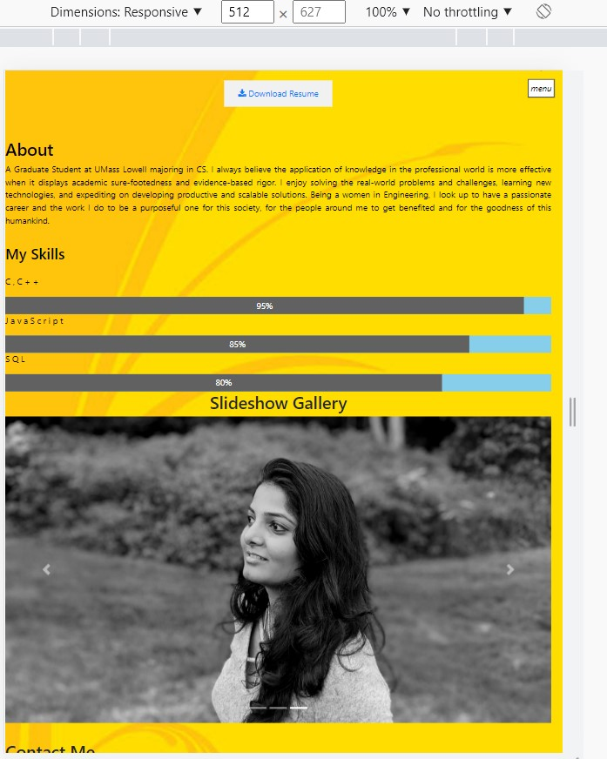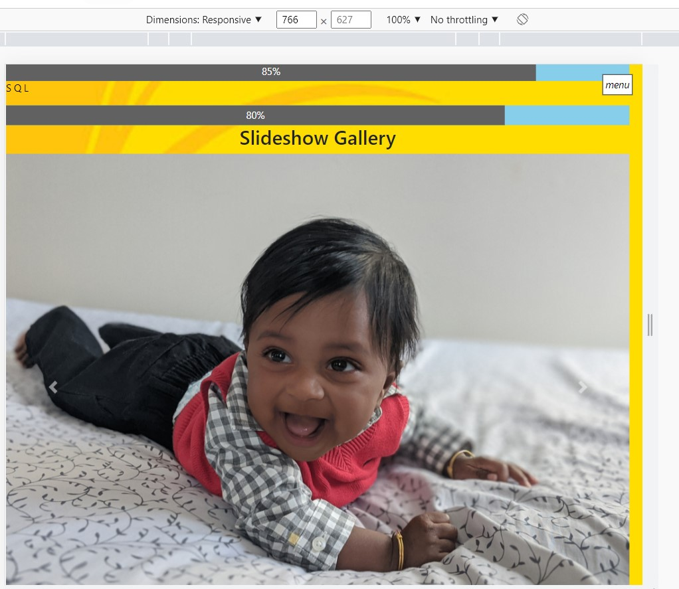

**FRONT-END - TECH STACKS**

* I am able to code with HTML, CSS, Sass and Bootstrap.
* I can now plan, develop, and code my own designs to give them the appearance I wish.
* It's a great PLUS to produce websites using both technical and non-technical skills.
* I enjoy designing with the intention of turning it into code. I can now produce designs that are realistic thanks to that.

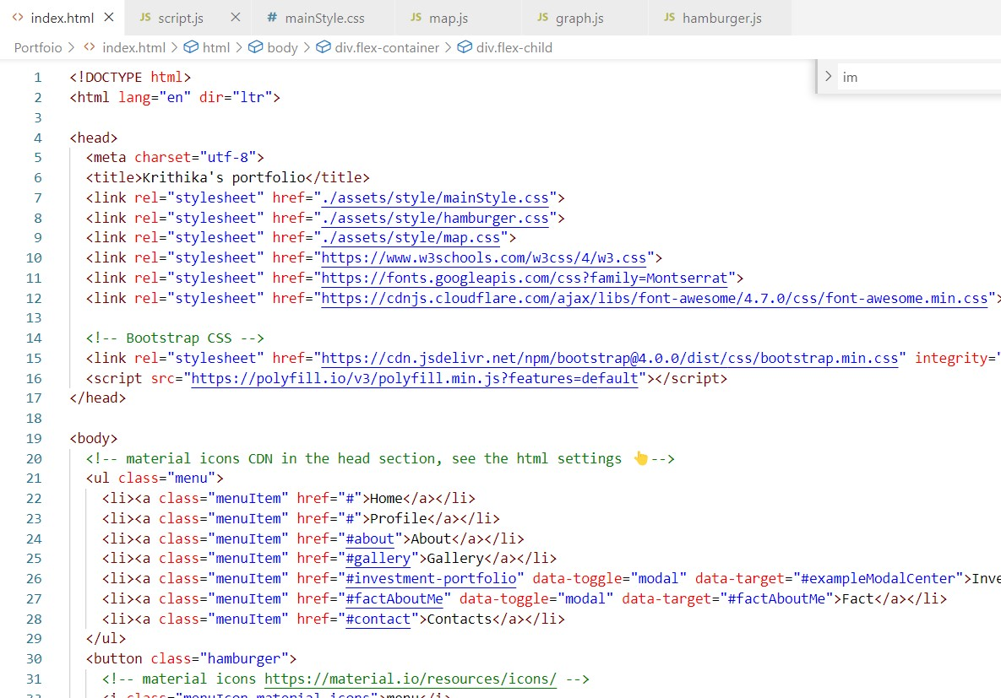

**LIBRARIES AND FRAMEWORK USED**

* Chart JS
  + <https://www.chartjs.org/>
* Google map
  + <https://developers.google.com/maps>
* Bootstrap
  + <https://getbootstrap.com/>
* Font-awesome
  + <https://fontawesome.com/>
* Google Fonts
  + <https://fonts.google.com/about>
* JQuery
  + <https://jquery.com/>

HIGH FIDELITY WIREFRAMES

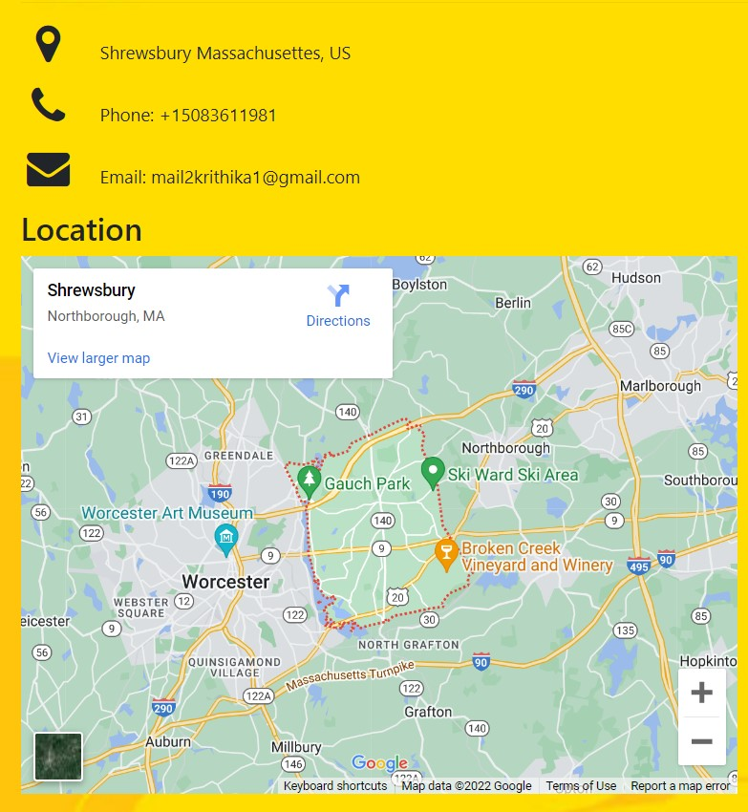

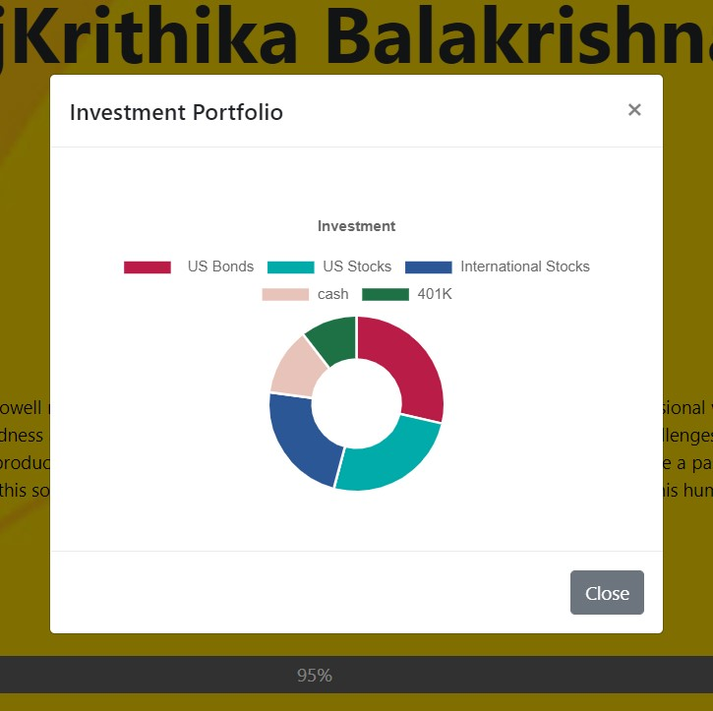

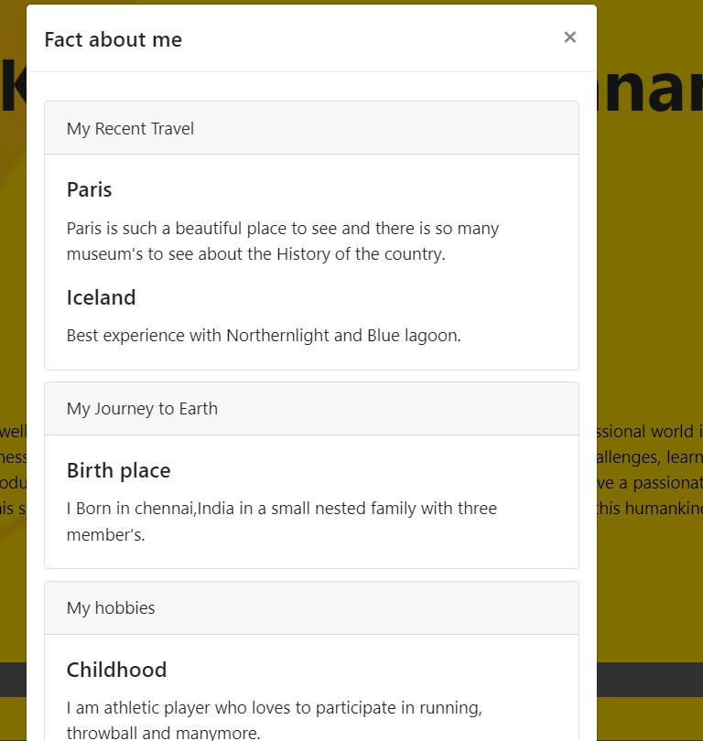

**VISUAL DESIGN**

I was able to create visuals to convey the application's content.

Investment Portfolio - This was a part of the project that I particularly enjoyed since

It's one of my interests to design.